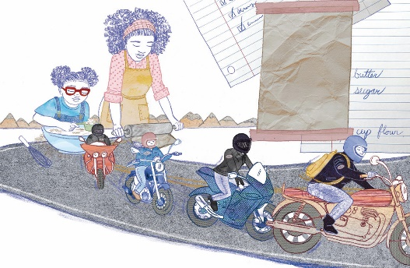
Charnelle Pinkney Barlow
“On Saturday I'm back at the café helping Mama” (p 21-22)
From Everything In Its Place, by Pauline David-Sax, Doubleday Books
for Young Readers, 2022
Colored pencil with digital collage
11 ½ x 17 ¼ inches
Courtesy of the artist
© Charnelle Pinkney Barlow

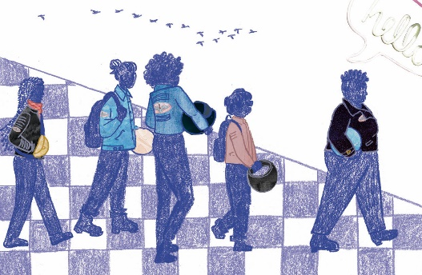
Charnelle Pinkney Barlow
“And when Maggie walks in, she's not alone,” (p 23-24)
From Everything In Its Place, by Pauline David-Sax, Doubleday Books
for Young Readers, 2022
Colored pencil with digital collage
11 ½ x 17 ¼ inches
Courtesy of the artist
© Charnelle Pinkney Barlow

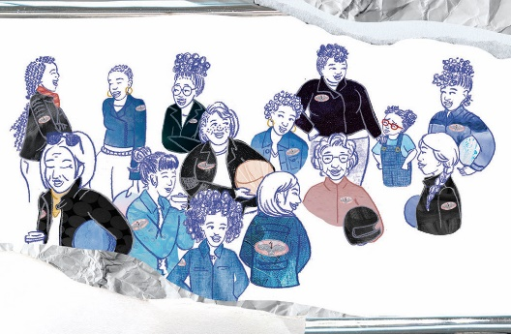
Charnelle Pinkney Barlow
“I'm confused. Sisters?” (p 25-26)
From Everything In Its Place, by Pauline David-Sax, Doubleday Books
for Young Readers, 2022
Colored pencil with digital collage
11 ½ x 17 ¼ inches
Courtesy of the artist
© Charnelle Pinkney Barlow

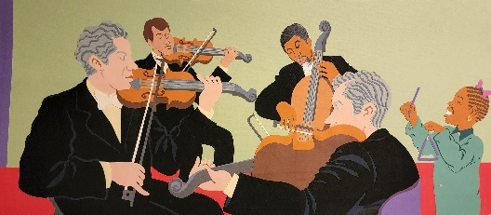
Elbrite Brown
“This is my dad.” (p 8-9)
From My Family Plays Music, by Judy Cox, Holiday House, 2003
Cut paper collage
19 ¾ x 31 7/8 inches
Courtesy of the artist
© Elbrite Brown

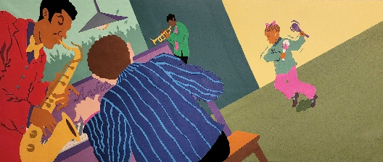
Elbrite Brown
“This is my uncle Woody.” (p 16-17)
From My Family Plays Music, by Judy Cox, Holiday House, 2003
Cut paper collage
19 ¾ x 31 7/8 inches
Courtesy of the artist
© Elbrite Brown

Elbrite Brown
“This is my cousin, Dean.” (p 24-25)
From My Family Plays Music, by Judy Cox, Holiday House, 2003
Cut paper collage
19 ¾ x 31 7/8 inches
Courtesy of the artist
© Elbrite Brown
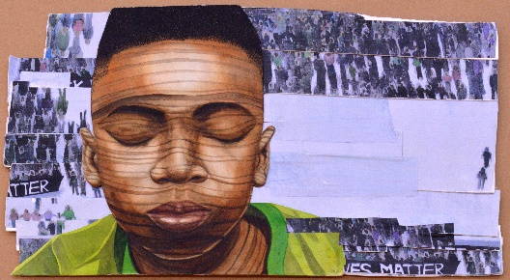
Bryan Collier
“Whispered Prayers” (cover, p 25-26)
From All Because You Matter, by Tami Charles, Orchard Books, 2020
Collage and Winsor & Newton watercolor paint on Arches watercolor paper
15 x 25 inches
Courtesy of the artist and R. Michelson Galleries
© Bryan Collier
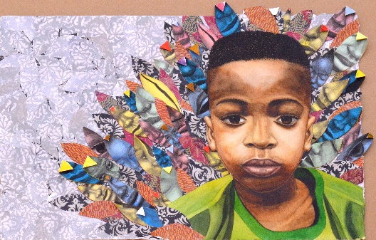
Bryan Collier
“You Were Born from Queens, Chiefs, Legends” (jacket, p 27-28)
From All Because You Matter, by Tami Charles, Orchard Books, 2020
Collage and Winsor & Newton watercolor paint on Arches watercp;pr paper
16 x 23 ½ inches
Courtesy of the artist and R. Michelson Galleries
© Bryan Collier

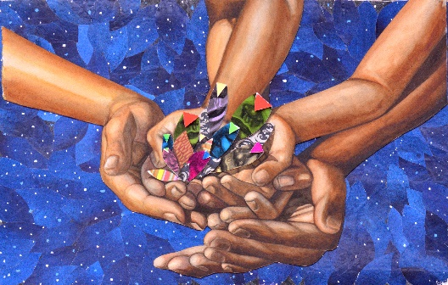
Bryan Collier
“You Are Sun Rays” (p 29-30)
From All Because You Matter, by Tami Charles, Orchard Books, 2020
Collage and Winsor & Newton watercolor paint on Arches watercolor paper
15 x 23 inches
Courtesy of the artist and R. Michelson Galleries
© Bryan Collier

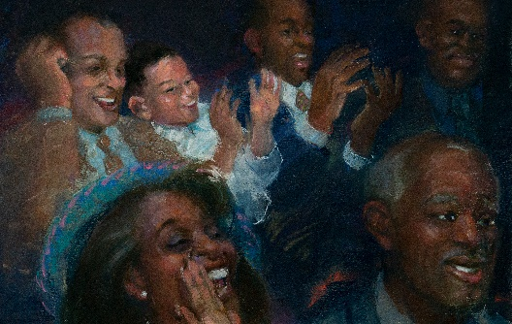
Gordon C. James
“Cheering for Jesse” (p 30-31)
From Just Like Jesse Owens, by Andrew Young and Paula Young Shelton, Orchard Books, 2022
Chalk pastels on Mi-Teintes pastel board
20 x 32 inches
Courtesy of the artist
© Gordon C. James

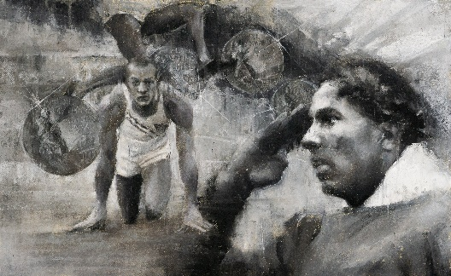
Gordon C. James
“4 Gold Medals” (p 32-33)
From Just Like Jesse Owens, by Andrew Young and Paula Young Shelton, Orchard Books, 2022
Chalk pastels on Mi-Teintes pastel board
20 x 32 inches
Courtesy of the artist
© Gordon C. James
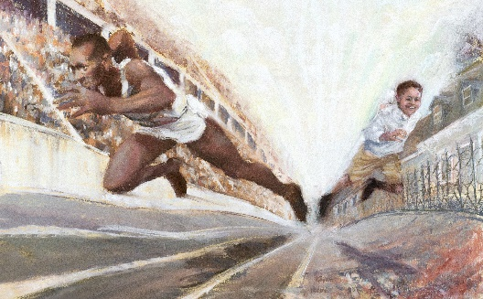
Gordon C. James
“Just Like Jesse Owens” (p 34-35)
From Just Like Jesse Owens, by Andrew Young and Paula Young Shelton, Orchard Books, 2022
Chalk pastels on Mi-Teintes pastel board
32 x 40 inches
Courtesy of the artist
© Gordon C. James

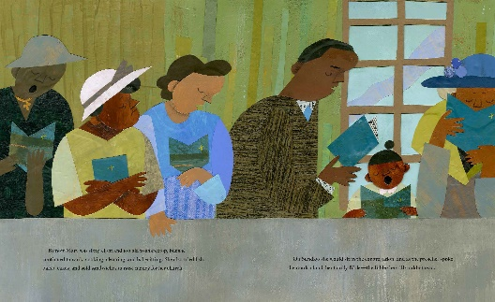
Oge Mora
“By now Mary was sixty-eight and too old to sharecrop” (p 19-20)
From The Oldest Student: How Mary Walker Learned to Read, by Rita Lorraine Hubbard, Anne Schwartz Books, 2020
Acrylic paint, china marker, colored pencil, patterned paper, and book clippings
9 x 18 inches
Courtesy of the artist
© Oge Mora

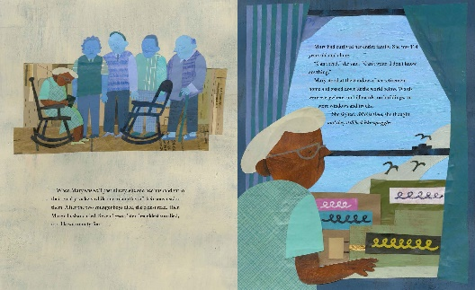
Oge Mora
“When Mary was well past ninety” (p 21-22)
From The Oldest Student: How Mary Walker Learned to Read, by Rita Lorraine Hubbard, Anne Schwartz Books, 2020
Acrylic paint, china marker, colored pencil, patterned paper, and book clippings
9 x 18 inches
Courtesy of the artist
© Oge Mora

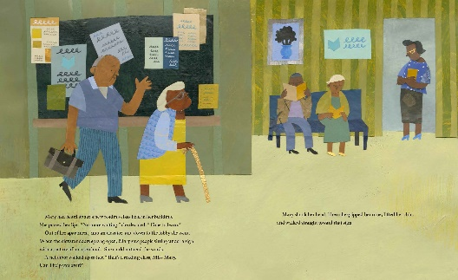
Oge Mora
“Mary had heard about a new reading class” (p 23-24)
From The Oldest Student: How Mary Walker Learned to Read, by Rita Lorraine Hubbard, Anne Schwartz Books, 2020
Acrylic paint, china marker, colored pencil, patterned paper, and book clippings
9 x 18 inches
Courtesy of the artist
© Oge Mora

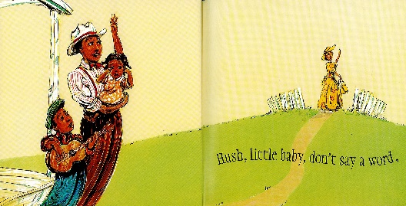
Brian Pinkney
“Hush, little baby, don't say a word,” (p 4-5)
From Hush, Little Baby, arranged by David Wolff, adapted by Brian Pinkney, Greenwillow Books, 2006
Colored inks on clayboard
12 x 24 inches
Courtesy of the artist
© Brian Pinkney

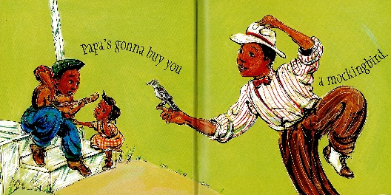
Brian Pinkney
“Papa's gonna buy you a mockingbird” (p 6-7)
From Hush, Little Baby, arranged by David Wolff, adapted by Brian Pinkney, Greenwillow Books, 2006
Colored inks on clayboard
12 x 24 inches
Courtesy of the artist
© Brian Pinkney

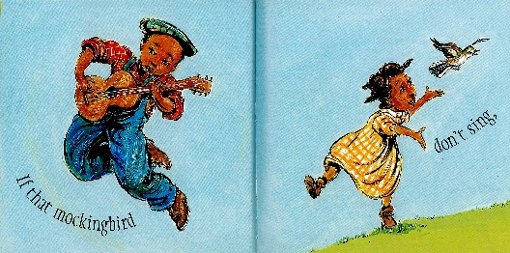
Brian Pinkney
“If that mockingbird don't sing” (p 8-9)
From Hush, Little Baby, arranged by David Wolff, adapted by Brian Pinkney, Greenwillow Books, 2006
Colored inks on clayboard
12 x 24 inches
Courtesy of the artist
© Brian Pinkney

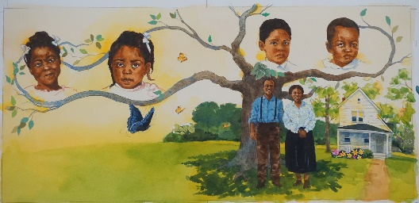
James E. Ransome
“You know… I believe that girl could fly” (p 7-8)
From On Her Wings: The Story of Toni Morrison, by Jerdine Nolen, Simon & Schuster Books for Young Readers, 2022
Watercolor and collaged papers
13 x 28 inches
Courtesy of the artist
© James E. Ransome

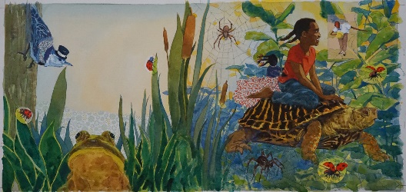
James E. Ransome
“Chloe was little then, just listening” (p 9-10)
From On Her Wings: The Story of Toni Morrison, by Jerdine Nolen, Simon & Schuster Books for Young Readers, 2022
Watercolor and collaged papers
13 x 28 inches
Courtesy of the artist
© James E. Ransome

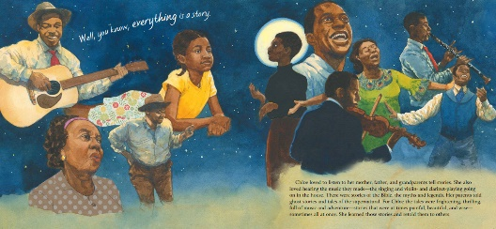
James E. Ransome
“Well, you know, everything is a story” (p 11-12)
From On Her Wings On Her Wings: The Story of Toni Morrison, by Jerdine Nolen, Simon & Schuster Books for Young Readers, 2022
Watercolor and collaged papers
13 x 28 inches
Courtesy of the artist
© James E. Ransome
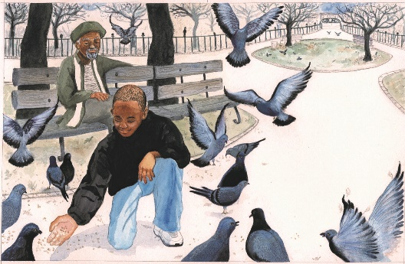
Shadra Strickland
“Mama and Papa named me Mehkai” (p 7-8)
From Bird, by Zetta Elliot, Lee & Low Books, Inc., 2008
Watercolor, gouache, charcoal, and pen
10 7/8 x 16 5/8 inches
Courtesy of the artist
© Shadra Strickland

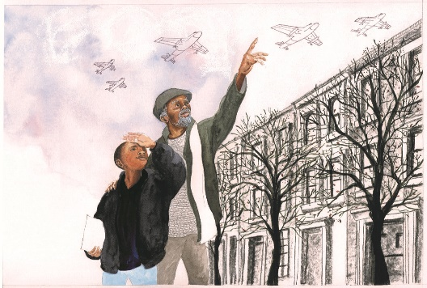
Shadra Strickland
“I like talking to Uncle Son” (p 9-10)
From Bird, by Zetta Elliot, Lee & Low Books, Inc., 2008
Watercolor, gouache, charcoal, and pen
10 7/8 x 16 5/8 inches
Courtesy of the artist
© Shadra Strickland

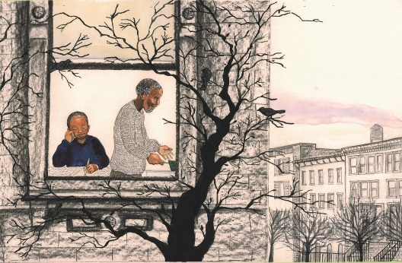
Shadra Strickland
“Sometimes on my way home from school” (p 11-12)
From Bird, by Zetta Elliot, Lee & Low Books, Inc., 2008
Watercolor, gouache, charcoal, and pen
10 7/8 x 16 5/8 inches
Courtesy of the artist
© Shadra Strickland

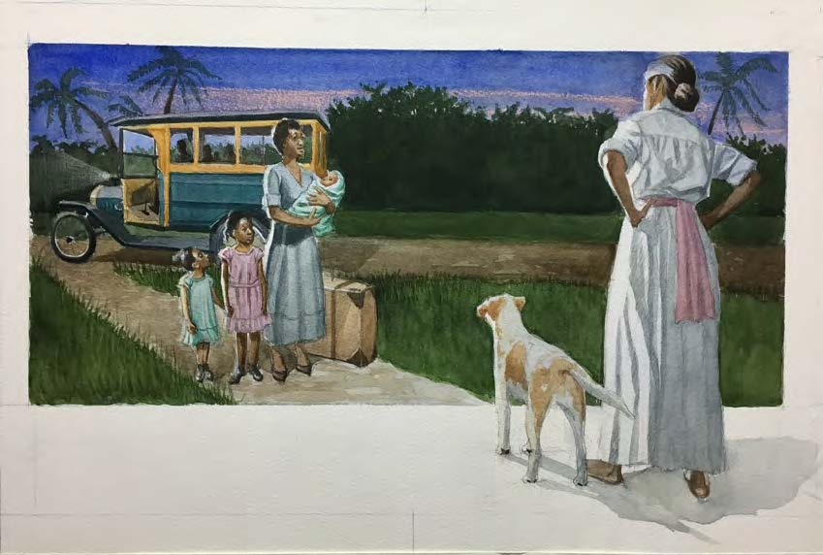
Eric Velasquez
“In 1928, Shirley, her sisters, and Mother” (p 8-9)
From She was the First! The Trailblazing Life of Shirley Chisholm, by Katheryn Russell-Brown, Lee & Low Books, 2020
Watercolor
15 x 22 inches
Courtesy of the artist
© Eric Velasquez

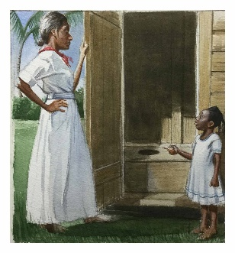
Eric Velasquez
“Island life was nothing like city living.” (p 10)
From She was the First! The Trailblazing Life of Shirley Chisholm, by Katheryn Russell-Brown, Lee & Low Books, 2020
Watercolor
15 x 11 inches
Courtesy of the artist
© Eric Velasquez

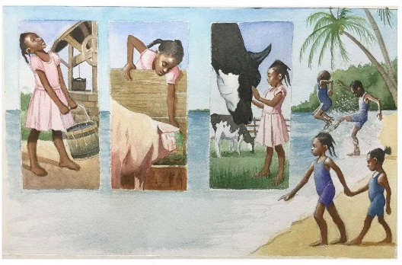
Eric Velasquez
“Grandmother Emmeline's house was stocked with love,” (p 12-13)
From She was the First! The Trailblazing Life of Shirley Chisholm, by Katheryn Russell-Brown, Lee & Low Books, 2020
Watercolor
15 x 22 inches
Courtesy of the artist
© Eric Velasquez

